**IT5182 Assignment One**

**Case Study**

**Introduction**

The scenario below describes the activities that take place in a travel agency called Dream Getaways. Use these details to construct the models described in the assignment one brief.

**Dream Getaways Scenario**

Dream Getaways is a business that helps people plan their vacation. Dream Getaways promotes resorts and matches customers with the resorts. Currently, Dream Getaways performs its booking service on paper but it would like to automate these processes.

**Interview Notes**

**Travel Agent:** The operational part of our business consists of two parts: we record resorts in our files and we book customers on vacations.

**Analyst:** Let's take a look at recording resorts. How does that happen?

**Travel Agent:** Well, suppose that a resort wants to advertise with us. They'll call us and talk to one of our travel agents. Then the travel agent will either create a new file for the resort or update an existing file if we already know about the resort.

**Analyst:** And the end result?

**Travel Agent:** The end result is that we have the resort information on our files.

**Analyst:** Good. Let's take a look at booking customers. How does that happen?

**Travel Agent:** Suppose a customer wants to go on vacation. The customer calls us and talks to a travel agent. The agent creates a new customer profile, or updates an existing profile if the customer has done business with us before. Then the agent searches for resorts that the customer might like and passes that information to the customer. When the customer decides on a resort, the agent creates a vacation record.

**Analyst:** So how do you deal with invoicing the customer and collecting payment?

**Travel Agent:** We have a separate system for that. I don’t want to deal with that here.

**Analyst:** Do you get feedback from the customers on how they liked their vacation?

**Travel Agent:** That’s a good idea. But let’s not work on that quite yet.

**Analyst:** Okay, let’s change topics a little. How many vacation reservations can any one customer have?

**Travel Agent:** Well, over time, more than one at least. We have a fair amount of repeat business, and sometimes a customer books two vacations before going on the first one.

**Analyst:** And for each vacation record, you’ll have several customers travelling on that vacation, right?

**Travel Agent:** Wait a minute. Even though it’s true in real life that a whole family goes on vacation together, we don’t track each person that’s going to the resort. We only care about the one customer who makes the booking.

**Analyst:** And how about the resorts? Certainly each resort is the destination for more than one vacation?

**Travel Agent:** Definitely.

**Analyst:** And can a vacation be a planned trip to more than one resort?

**Travel Agent:** Not in our business. We only book vacations that are for one resort.

If a person wants to go to two resorts, that customer needs two vacation records.

**Analyst:** Thanks, that’s an important point.

OK, what would be very useful for me at this stage is to have a look at the paper forms that you currently use at Dream Getaways.

**Travel Agent:** Sure. I thought you might need them and so I’ve collected together all the forms we currently use (*shown overleaf*). I’ve also added a few notes on how we use them.

**Analyst:** Great! I’ll take a close look at them this afternoon.

Well, many thanks for the information you provided today. I’ll get back to you once I’ve modelled the requirements for your new system.

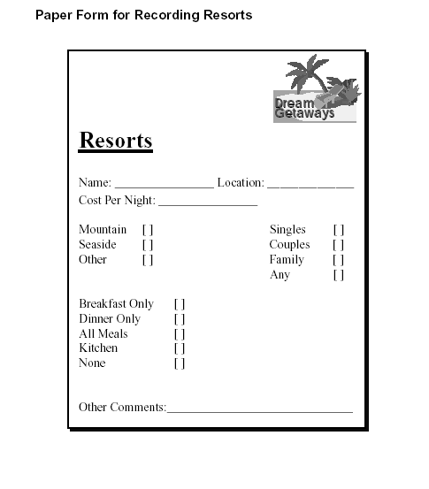

We use this form to record details about a resort. **Mountain**, **Seaside** and **Other** are the *Locale* options of a resort. **Breakfast**, **Dinner** **Only**, **All Meals**, **Kitchen** and **None** relate to the *Meal Service* option provided by the resort. Finally, **Singles**, **Couples**, **Family** and **Any** refer to the *Lifestyle* option of the resort. For each category (Locale, Meal Service and Lifestyle), we tick just one of the options listed on the form.

**Hint: You will need one column for each category to record these details.** 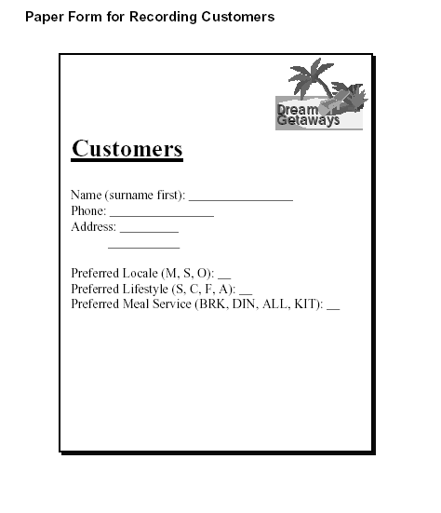

The Codes used for *Preferred Locale* (**M, S** and **O**) relate to Mountain, Seaside and Other, respectively. These are the same details collected in the Resorts form.

The codes used for *Preferred Lifestyle* (**S, C, F** and **A**) relate to Singles, Couples, Family and Any, respectively. (See the resorts form).

The codes used for *Preferred Meal Service* (**BRK, DIN, ALL** and **KIT**) relate to Breakfast, Dinner Only, All Meals and Kitchen, respectively. (See the resorts form).

We record one of the above codes for the Locale, Lifestyle and Meal Service preference of each customer.

**Hint: You will need one column for each category to record these details.**

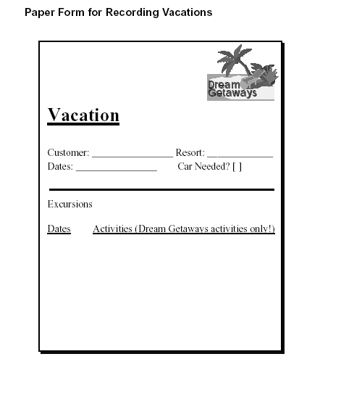

Note: Each vacation may be associated with a number of excursions. The date and activity of each excursion is listed in the above form. Examples of excursions might be Water Skiing, Wine Tours and Guided Mountain Walking etc.